Letter of Commitment to be Received From Companies that Trade with Russia

To Denizbank A.Ş.
Bahrain Branch,

For any transfers, payments, financing, foreign trade that we will carry out at home and/or abroad from our accounts that are available at your bank and will be opened thereafter; we agree, declare and warrant that we will not use our accounts with your bank in any way related to international blacklists and sanction laws related to Ukraine-Russia sanctions, prohibited person/firm, prohibited counterparty and any prohibited element (prohibited zone/bank/sector/ship/port/prohibited goods and/or services).

In addition to our commitments above; through our accounts in your bank, we accept, declare and commit the following;

- For a good or service that is prohibited from being imported from Russia by the United States (“USA”), the European Union (“EU”) and/or the United Kingdom (UK);
- If imported from Russia, we will not export these goods directly or through Turkey to countries that impose sanctions,
- In case of importation from third countries, we will not export directly or through Turkey to countries that impose sanctions,
- That these goods will only be used/consumed within Turkey,

- For a good or service that is prohibited from being exported to Russia by the United States, the EU and/or the UK;
- In case imports are made from sanctioned countries (USA, EU/or UK), we will not export these goods directly or via Turkey to Russia,
- In case of importing goods from third countries (originating in USA, EU, G7 and/or UK), we will not export these goods directly or via Turkey to Russia,

- In our direct or indirect trade with Russia (in the case of selling goods to a trader or distributor located outside of Russia), we do not operate in the specified sectors listed in the following annexes (Specified sectors), and we will not mediate any transaction of the sale, transportation, maintenance/repair or transfer of dual use goods to Russia as in High Priority Items and Specified Items in the below annexes and Dual use Items listed in the link below.

- In our direct or indirect trade with Russia (in case of selling goods to a trader or distributor located outside of Russia);
- We will not trade, finance or process any goods related to Russia’s Military-Industrial Base, and the final buyer of the goods we sell has no connection with firms operating in Russia’s military/defense industry,
- We will conduct regular follow-up and detailed inspection of the companies we sell goods to, and as a result, if we detect any relationship with the persons & companies listed in the prohibited lists and/or related to the military-industrial base of Russia, we will terminate our relationship immediately and we are responsible for sharing the situation with your Bank immediately,

- Any parts/sections or raw materials in the product we sell to Russia or used in the construction of the product does not contain any raw materials originating in the USA and/or EU/UK, the goods are not subject to EAR (goods originating in USA or not originating in USA but more than 25% of their material value originating in USA),

- We will not trade in transit to any country related to goods and services subject to export/import bans by the USA, EU, G7, UK in relation to Russia,

- In the transactions we carry out from your bank, we will provide complete information and documents related to trade.

We acknowledge, declare and undertake that after the signature date of this commitment, all of our obligations and commitments under this commitment will be valid for all countries to be sanctioned by the Republic of Turkey, the United Arab Emirates (“UAE”), the United Nations (“UN”), the EU, the United Kingdom or OFAC.

We irrevocably accept to be responsible for any fines that may be imposed on your Bank by the official institutions as a result of our contradiction of the above statements and commitments, for any damages and their secondary’s caused for your bank, and we will pay these fines and damages to your bank immediately with default interest on your first written request; and we acknowledge and undertake that you can collect the relevant amounts without any prior notice from our accounts via your bank, that we know that contradiction of our commitments will constitute a violation of the Core Banking Services Agreement concluded with your Bank, and that you can close our accounts at your bank.

This commitment is an integral part of the commitment to Compliance with Sanctions of Russia and the Embargoed Countries.

__ / __ / ____

Best regards,

(Company Title/Stamp and Authorized Signature)

Annex 1: High Priority Items
Annex: 2: Certain Items

Annex 1: High Priority Items
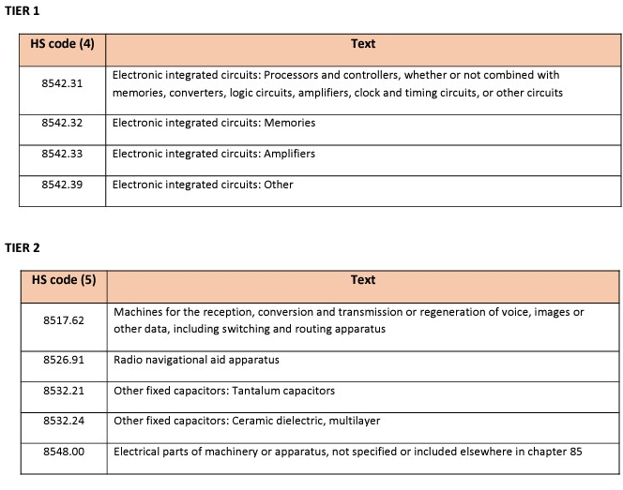
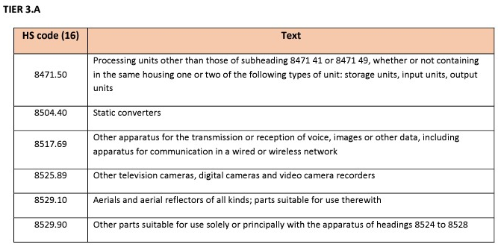

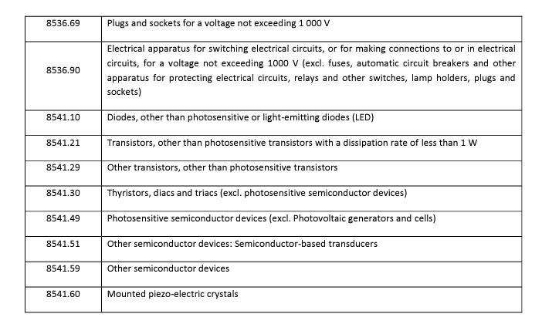
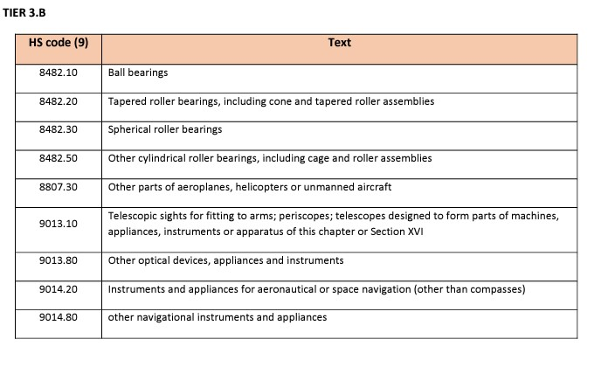
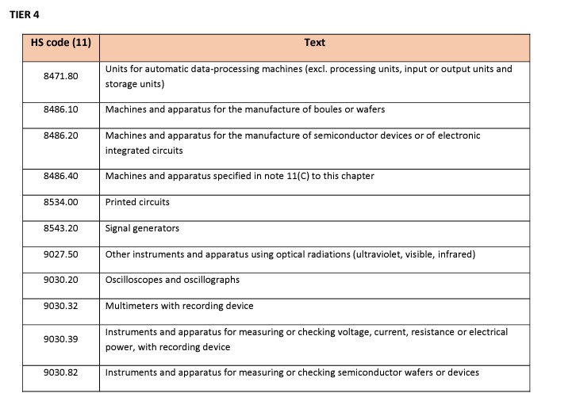

Annex 1: High Priority Items
TIER 1
HS Code (4) | Explanations
8542.31 | Electronic integrated circuits: Processors and controllers (with or without memory, converters, logic circuits, amplifiers, clock and timing circuits, or other circuits)
8542.32 | Electronic integrated circuits: Memories
8542.33 | Electronic integrated circuits: Amplifiers
8542.39 | Electronic integrated circuits: Other

TIER 2
HS Code (5) | Explanations
8517.62 | Machines for receiving, translating, and transmitting or recreating audio, video, or other data, including connecting lines and routing devices
8526.91 | Radio Navigation Auxiliary devices
8532.21 | Other fixed capacitors: Tantalum capacitors
8532.24 | Other fixed capacitors: Ceramic dielectric, multi-layer
8548.00 | Electrical components of machines or devices not specified or available anywhere in the 85th chapter

TIER 3.A
HS Code (16) | Explanations
8471.50 | Processing units other than those under subheadings 8471.41 or 8471.49 (whether or not one or two of the types of memory units, input units, output units in the same container)
8504.40 | Static converters
8517.69 | Other devices for transmitting or receiving voice, video, or other data, including a communication device on a wired or wireless network
8525.89 | Other television cameras, digital cameras and video recorder cameras
8529.10 | All types of antennas and aerial reflectors, suitable for use with them
8529.90 | Other components suitable for use on devices from 8524 to 8528
8536.69 | Plugs and sockets for voltage not exceeding 1000 Volts
8536.90 | Electrical equipment for switching or maintaining electrical circuits with a voltage not exceeding 1000 volts or for plunging connections into or from an electrical circuit (e.g. fuses, automatic circuit breakers and other equipment, relays and other switches to protect electrical circuits, bulb receptacles, plugs, sockets)
8541.10 | Diodes other than light-sensitive or light-emitting diodes (LEDs
8541.21 | Transistors other than light-sensitive transistors with a dispersion rate of less than 1 W
8541.29 | Other transistors, except light-sensitive transistors
8541.30 | Transistors, diodes and triangles (except light-sensitive semiconductor devices)
8541.49 | Light-sensitive semiconductor devices (excluding photovoltaic generators and cells)
8541.51 | Other semiconductor devices: Semiconductor-based converters
8541.59 | Other semiconductor devices
8541.60 | Assembled piezoelectric crystals

TIER 3.B
HS Code (9) | Explanations
8482.10 | Ball bearings (bearings)
8482.20 | Tapered roller bearings (including tapered rings and roller assemblies prepared for assembly)
8482.30 | Drum roller bearings (bearings)
8482.50 | Other cylindrical roller bearings (including cage and roller mounts)
8807.30 | Aircraft, helicopters or other parts of unmanned aircraft
9013.10 | Telescopic binoculars for weapons; periscopes; in this chapter or under section XVI; Telescopes constructed to form part of machinery, tools, devices or assemblies
9013.80 | Other optical instrument, device and assembly
9014.20 | Instruments and devices for aerial or space navigation (excluding compass)
9014.80 | Other navigational tools and devices

TIER 4
HS Code (11) | Explanations
8471.80 | Units of automated computing machines (excluding processing units, input or output units, and storage units)
8486.10 | Machines and devices for the manufacture of discs or ingots
8486.20 | Machinery and devices for the manufacture of semiconductor assembly or electronic integrated circuits
8486.40 | Machines and devices specified in note 11 (C) of this chapter
8534.00 | Thrust circuits
8543.20 | Signal generators
9027.50 | Other instruments and devices with optical rays (UV, visible rays, IR)
9030.20 | Oscilloscopes and oscillographs
9030.32 | Multimeters with recorder assembly
9030.39 | Instruments and devices for measuring or controlling voltage, current, resistance or power (those with logger assembly)
9030.82 | Tools and devices for checking or measuring semiconductor discs or assemblies

Annex 2: Specified Items (E.O. 14114 of Dec, 23)
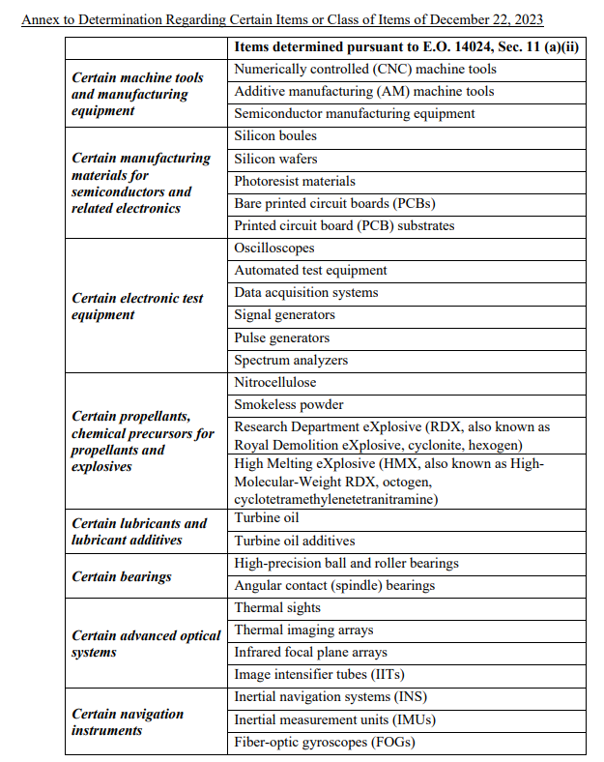

Annex 2: Specified Items
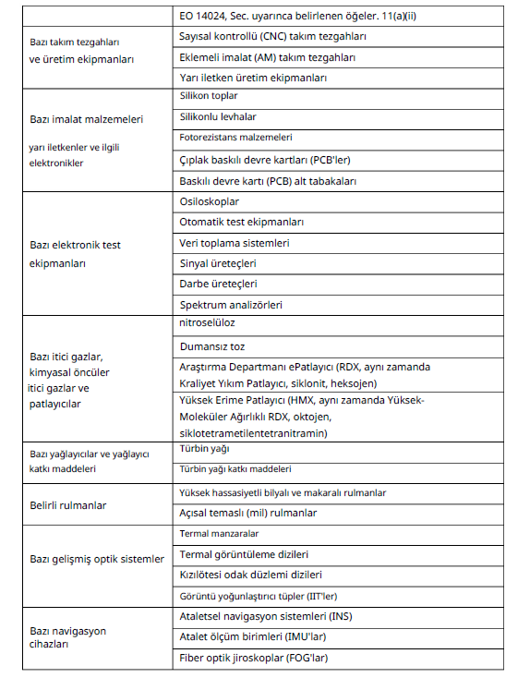

US (OFAC) announcement link on High priority items:
https://finance.ec.europa.eu/system/files/2023-09/list-common-high-priority-items_en.pdf
US (OFAC) announcement link related to specified items:
https://ofac.treasury.gov/media/932436/download?inline
Link to the Dual use Goods List:
https://eur-lex.europa.eu/legal-content/EN/TXT/?uri=CELEX%3A02009R0428-20211007

EU: In accordance with article 3 numbered 833/2014 (EU) as amended by Regulation 2022/428 (EU) No. XVIII, the sale, supply, transfer or export of luxury goods listed in the Annex exceeding EUR 300 per part is prohibited unless specified in the Annex.

OFAC: Some prohibited imports, exports and new investments under the violation of the Russian Federation, which continues by decree of 11 March 2022; (ii) the export, re-export, sale or supply of luxury goods or other goods to be determined by the Ministry of Commerce in consultation with the State Department and the Treasury Secretariat to any person in the Russian Federation, directly or indirectly from the United States or from a U.S. person residing anywhere, is prohibited.

According to the Bureau of Industry and Security (BIS) of the U.S. Department of Commerce, luxury goods; luxury cars; yachts; gemstones; jewelry; other fashion accessories; cosmetics; perfumes; furs; designer clothes; luxury watches; carpets and insulated covers hung on the wall; electronic entertainment software and equipment; recreational sports equipment; tobacco; wine and other alcoholic beverages; musical instruments; art; and antiques and collectible products, including but not limited to rare coins and stamps, are subject to a general rejection policy. In the Regulations of the Export Administration under 746, for clothing and shoes considered “Luxury goods” listed under section 5, a license is required when the unit value of each garment or a pair of shoes is equal to or greater than USD 1,000 (wholesale price), as specified in A1. There is no minimum dollar value for other ‘luxury goods’ listed in No. 5.

